43.24: a) 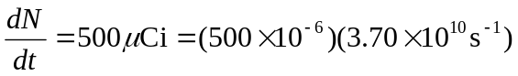
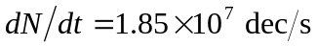
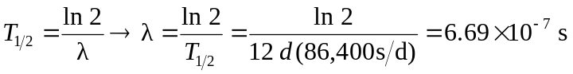
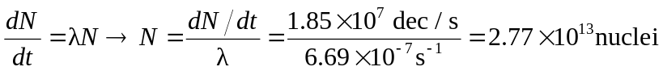
The mass of this 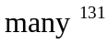Ba nuclei is
(b) 